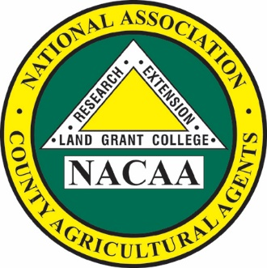

Keith Mickler

*President*

109th Annual Meeting

July 14-18, 2024

Dallas, Texas

*NACAA is an Equal Opportunity*

*Professional Association*

**National Association of County Agricultural Agents**

NACAA Headquarters

6584 W. Duroc Road

Maroa, IL 61756

Phone: 217-794-3700 Fax: 217-794-5901

Email: <exec-dir@nacaa.com>

www.nacaa.com

President’s Address

Keith Mickler

12 East 4th Ave., Suite 107  
Rome, GA 30161  
Phone: 706.295.6210 Cell:  706.622.8826  
Email: [**mickler@uga.edu**](mailto:mickler@uga.edu)